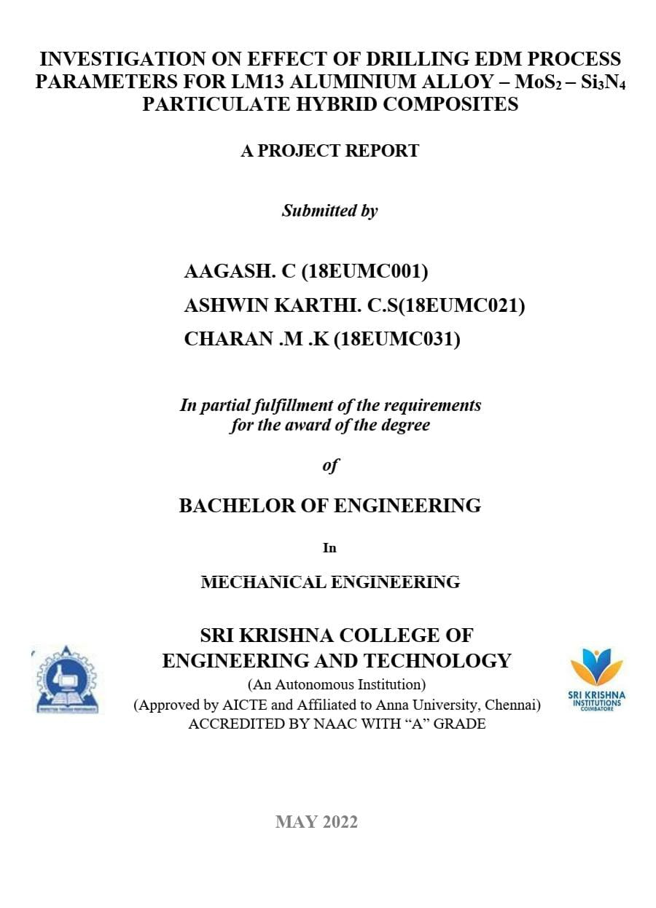
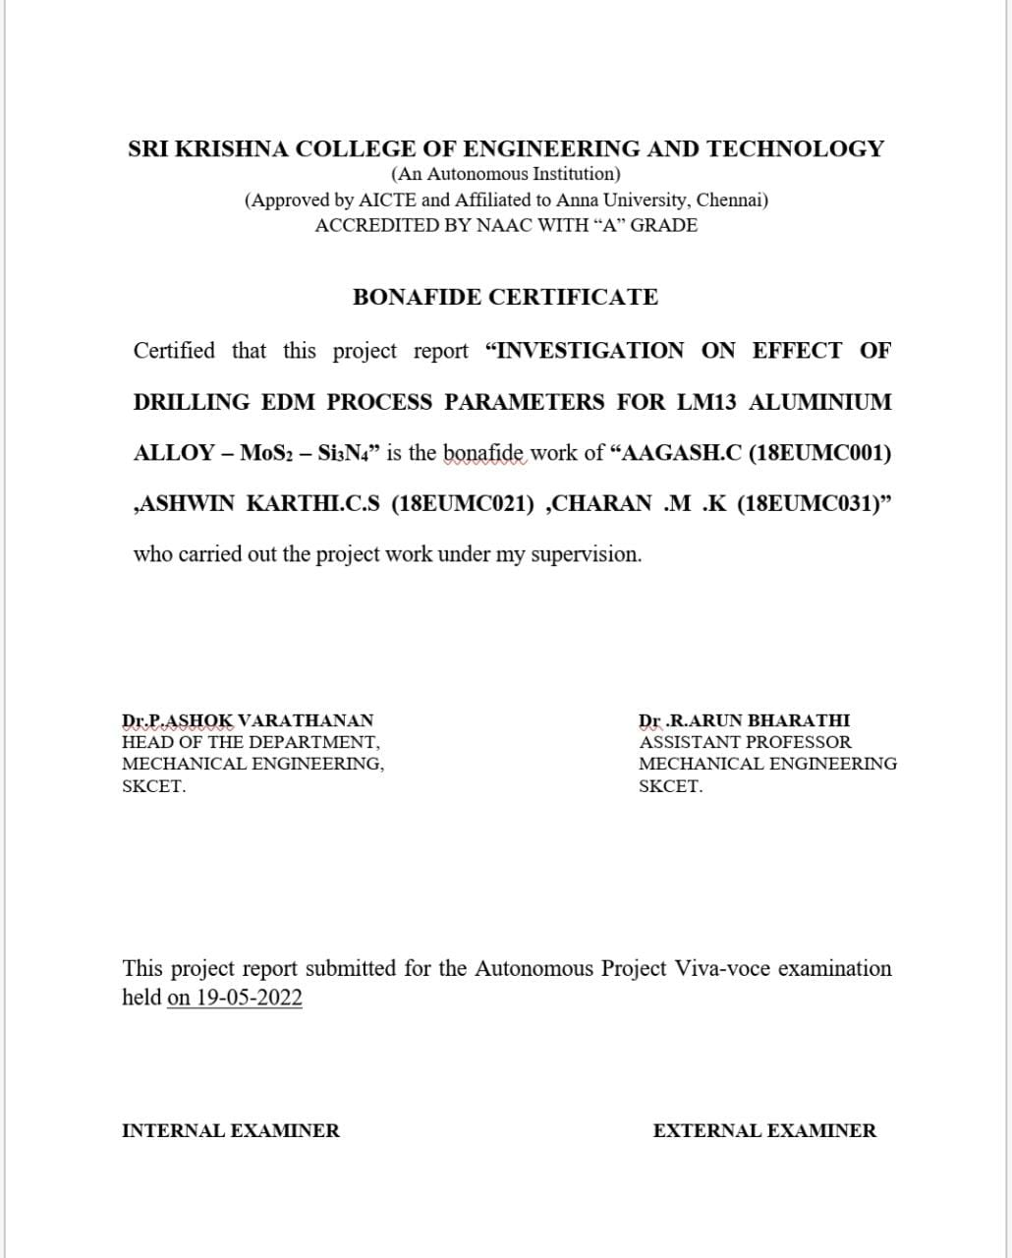


INDEX
1. Introduction
2. Literature review
3. Materials and methods
3.1. Materials
3.1.1. Mechanical Characteristics
3.1.2. Casting Characteristics
3.1.3. Application
3.2. Reinforcements
3.2.1. Molybdenum disulfide
3.2.2. Silicon nitride
3.3. Material preparation
3.4. Component fabrication
3.5. Drilling EDM machine setup
3.5.1. General specification about EDM machine
3.5.2. Experimental parameters and their levels
3.5.3. Experimental design for machining LM13–10Si₃N₄– 5MoS₂ composites
3.6. Evaluation method of machining performances
3.6.1. Material removal rate
3.6.2. Electrode wear rate
3.7. Response surface methodology
4. Results and discussion
4.1. Electric discharge machining
4.2. Effect of independent process variables on MRR
4.3. Effect of independent process variables on EWR
5. Conclusion
6. Reference

Abstract
In this study, the ceramic particles of Molybdenum disulfide (MoS₂) and Silicon nitride (Si₃N₄) (were used as reinforcements in LM13 alloy matrix to fabricate hybrid composites. The composites along with unreinforced aluminium alloy were produced by varying the weight percentage (wt%) of Si₃N₄ (0, 2.5, 5,7.5 and 10) with a constant 5wt% MoS₂ through liquid metallurgy stir casting technique. In LM13 alloy matrix.LM13 aluminium alloy-based hybrid composite (5 wt% MoS₂ of and 10 wt% of Si₃N₄ ), the machinability investigation is carried out using EDM (electric discharge machining) drilling route with copper and brass electrode. During experimentation, the process variables, namely current (I), pulse on-time (Ton) and pulse of-time (Tof), are varied and the output performance characteristics, viz. material removal rate (MRR), electrode wear rate (EWR) are measured. The series of experiments (20 runs) are formulated through the adoption of response surface methodology (RSM)-based full-factorial central composite design. To recognize the correlation between the process variables and performance characteristics, a mathematical model is developed for each response.

CHAPTER 1
1. INRODUCTION
A composite can simply be defined as a combination of two or more dissimilar materials having a distinct interface between them such that the properties of the resulting material are superior to the individual constituting components. Aluminium-based metal matrix composites (AMMCs) are being increasingly used in aerospace, automobile industry due to the enhanced properties such as elastic modulus, low density, tensile strength and wear resistance. Nowadays Aluminium metal matrix composites are increasing for making automobile spares and aerospace technologies due to their enhanced properties. The kind of reinforcement has a considerable effect on the mechanical and structural properties of the composites. There is a strong dependence on the kind of reinforcement and its volume fraction. However, the ductility of the metal matrix composites (MMCs) deteriorates with increase in ceramic particle concentration.1–3 Therefore, researchers focus their attention on the nanosized ceramic particles with an objective to strengthen the metal matrix, along with good ductility. When compared with the corresponding MMCs, the properties of MMNCs would be enhanced considerably even with lower volume fraction of nanoparticles. It has already been reported that MMNCs could especially provide a significantly improved performance at elevated temperatures. The trend is towards safe usage of the MMC parts in the automobile engine, which work particularly at high temperature and pressure environments. Particulate reinforced MMCs have been the most popular MMCs over the last two decades. Of these, ceramic reinforced Al-based MMCs are the most common. Although the incorporation of a second phase into a matrix material can enhance the physical and mechanical properties of the latter, it could also significantly change the corrosion behaviour.
Particulate reinforced Al-based MMCs find potential applications in several thermal environments, especially in automobile engine parts such as drive shafts, cylinders, pistons, and brake rotors. Al-based MMCs which are used in automobile engine parts normally encounter acidic environments containing chloride, sulphiate and nitrate radicals, in addition to exhaust gases like CO2, CO and NOx. MMCs used at high temperatures should have good mechanical properties and resistance to chemical degradation in air and acidic environments. For high-temperature applications, it is essential to have a thorough understanding of the corrosion behaviour of the aluminium composite. The final mechanical properties of a metal matrix composite depend upon the uniform distribution of the reinforcement particle. In order to achieve homogeneous distribution, many researchers have adopted various techniques such as mechanical alloying, casting, and powder metallurgy (PM). Among all fabrication techniques the composites were fabricated through the Stir Casting technique. Actually net shaped components of complex shape with high accuracy.Out of these two methods liquid phase process is more effective and efficient than solid state because solid state process is time consuming and costly and of the solid state process stir casting is very simple, most cost effective method and its cost is very low as compared to other method in case of mass production. Consequently, in the present time, stir casting is the greatest viable and prevalent method for the fabrication of the particulate-reinforced AMMCs. For mechanical alloying, Stir casting, as an alternative and relatively simple route can be successfully used to produce metal matrix composite. Selection of the processing method depends on the property requirements, cost factor consideration and future applications prospects. Incorporation of hard second phase particles in the alloy matrices to produce metal matrix composites has also been reported to be more beneficial and economical due to its high specific strength and corrosion resistance properties.The fabrication technique are available in solid state and liquid state methods, spray deposition technique but every methods has their unique fabricating routes out of these liquid method especially stir casting method has prominently an economic and has many varieties of combination and processing conditions. Stir casting is a liquid metallurgy method of composite material fabrication, in which a dispersed phase like ceramic particles, short fibers is mixed with a molten matrix metal by means of a mechanical stirring. The stir casting arrangements is shown in figure. It is effectively mixing the reinforcement material with the matrix material (i.e. Al alloy) and does not damage the reinforcements while stirring. Stir casting provides better bonding between matrix andreinforcing material due to the stirring action. Stir casting, as an alternative and relatively simple route can be successfully used to produce metal matrix composite. A recent development in stir casting process is a double stir casting or two-step mixing process. Currently SiC, Al2O3, B4C, Si3N4, ZrB2, AIN , TiC and ZrO2 are extensively used to reinforce aluminium metal matrix composites, to impart improved mechanical properties. Moreover, aluminium matrix composites reinforced with a combination of micro-sized and nano-sized reinforcement have gained special research attention because of their improved mechanical and tribological properties, making them a better alternative than single reinforced composites. Hybrid composites with micro-sized and nano-sized reinforcement play an important role when used as frictional materials. Among several ceramic reinforcements, Si₃N₄ and MoS₂ has been widely used by recent researchers because it enhances tribological and mechanical properties. However, the enhancement in the properties of Al/ Si₃N₄ /MoS₂ composites occurs at 2 the expense of ductility and fracture toughness. Ductility and fracture toughness are important material properties that are necessary in preventing catastrophic failure in service. In addition, metal oxide shifts the brittleness of MoS₂ and enhances the fracture toughness Al-Si₃N₄ -MoS₂ of composites when used as a reinforcement in hybrid composites, as reported in previous studies. Metal oxides are also economical, widely available. This makes Al-Si₃N₄ -MoS₂ as one of the irreplaceable composite in the automotive industry due to the fact that the main characteristics of the connecting rod are e-modulus, density and wear resistance. This composite’s usage in the brake disc reduces the unsprung weight of the vehicle. The other applications of Al-Si₃N₄ -MoS₂ are in cylinder liners and in parts of valve train . The enhancements of such properties in Al-Si₃N₄ -MoS₂ are wholly relying on the homogenous distribution of these reinforcements in aluminium. The stir casting is a liquid based MMC fabrication in which the dispersed reinforcements in the metal matrix are mixed by the help of the mechanical stirrer. It is beneficial as it is simple, flexible and efficient in mass production. An aluminum extrusion alloy is simply a mixed metal, made from a predetermined mixture of one or more elements together with aluminum. Some of the common elements alloyed with aluminum include copper, magnesium, manganese, chromium, silicon, iron, nickel, and zinc. These alloying elements are usually added to aluminum in amounts ranging from 0.05 to 7.0 percent. Product performance is determined in part by the alloy composition and in part by the method of production and thermal treatments. Structural and certain physical properties are influenced significantly by the choice of alloy and temper.
Electric discharge machining is a thermo-electric non-traditional machining process. Material is removed from the workpiece through localized melting and vaporization of material. Electric sparks are generated between two electrodes when the electrodes are held at a small distance from each other in a dielectric medium and a high potential difference is applied across them. Localized regions of high temperatures are formed due to the sparks occurring between the two electrode surfaces. Workpiece material in this localized zone melts and vaporizes. Most of the molten and vaporized material is carried away from the inter-electrode gap by the dielectric flow in the form of debris particles. To prevent excessive heating, electric power is supplied in the form of short pulses. Spark occurs wherever the gap between the tool and the workpiece surface is smallest. After material is removed due to a spark, this gap increases and the location of the next spark shifts to a different point on the workpiece surface. In this way several sparks occur at various locations over the entire surface of the workpiece corresponding to the workpiece-tool gap. Because of the material removal due to sparks, after some time a uniform gap distance is formed throughout the gap between the tool and the workpiece.If the tool is held stationary, machining would stop at this stage. However if the tool is fed continuously towards the workpiece then the process is repeated and more material is removed. The tool is fed until the required depth of cut is achieved. Finally, a cavity corresponding to replica of the tool shape is formed on the workpiece.
Hole making has long been recognized as one of the most important machining processes. Approximately 30% of production time is spent in making holes. Because untouched machining characteristic EDM has superiority to small hole machining, any conductive material with any hardness can be machined by EDM. Blind hole, deep hole, inclined hole and profiled hole can be machined. In addition, because surface machined by EDM has a series of discharge caves and there is no spiral trace obtained by ordinary drilling processing, flow field distribution of liquid or gas flowing through small holes can be improved greatly. So, EDM can be used as an effective means for small hole machining in some special applications
Small hole EDM (electric discharge machining) drilling, also known as fast hole EDM drilling, hole popper, and start hole EDM drilling, was once relegated.o a last resort method of drilling holes. Now small hole EDM drilling is used for production work. Holes can be drilled in any electrical conductive material, whether hard or soft, including carbide. EDM drilling is well established in the field of manufacturing metal pieces with complicated geometries. It has vast applications like putting holes in turbine blades, fuel injectors, cutting tool for coolant, hardened punch ejector. It is also used to remove broken tools in small holes, making plastic mold vent holes, wire EDM starter holes, mini machines/robots and air vent holes for forging dies. The same can be utilized for dovetail finger pin removal, cross key pin removal, balance hole drilling, removal of steam strainer rivets etc.
In a highly competitive world of testing and evaluation, an efficient method for testing many factors is needed. Design of experiments is a series of tests in which purposeful changes are made to the input variables of a system or process and the effects on response variables are measured. Design of experiments is applicable to both physical processes and computer simulation models. Experimental design is an effective tool for maximizing the amount of information gained from a study while minimizing the amount of data to be collected. Therefore by using Design of Experiments the best parameter combination is sorted.

CHAPTER 2

2.LITERATURE REVIEW
In the present decade, it is found from the literatures that there is a constant growth of interest on in situ methods for the production of new MMCs
Han et al developed Al–12Si alloy reinforced with TiB2 produced by in situ reaction between K2TiF6 and KBF4 salts. Liuzhang et al.fabricated Al–12Si alloy reinforced with Al2O3 by decomposing Al2 SO4 3 in molten aluminium alloy and reported uniformly distributed fine particulate reinforcements.
Hosein and Meratian developed pure aluminium reinforced with Al2O3 by the in situ reaction of copper oxide and glass powders and found that the strength of composites was significant at 300*C.
Tyagi fabricated pure aluminium reinforced with TiC by the in situ reaction of SiC and Ti powders and reported that the wear rate of AMMC decreased linearly with the increasing volume fraction of TiC.
Shyu and Ho developed Al–5.1Cu alloy reinforced with TiC by the in situ reaction of Al–5.1Cu–6.2Ti alloy and carbonaceous gas and found significant enhancement of mechanical and wear properties of AMMC.
Sheibani and Najafabadi produced pure aluminium reinforced with TiC in whisker form resulted from the in situ reaction among graphite, TiO2 and Na3AlF6. Birol fabricated Al–Ti alloy reinforced with TiC by the in situ reaction between graphite and K2TiF6.
Zhang et al. developed A356 reinforced with Al3Zr and ZrB2 by the in situ reaction betweenK2ZrF6 and KBF4 salts and reported that wear rate of composites decreased with the increase in percentage ofreinforcements.
Herbertetal.developedAl–4.5CualloyreinforcedwithTiB2bytheinsitureaction between K2TiF6 and KBF4 salts. Ramesh et al. Fabricated AA6063 MMCs reinforced with TiB2 by the reaction between Al–10Ti and Al–3B alloys andfound that the AMMC had higher mechanical properties especially with very high ductility than aluminium matrix.
Naveen Kumar et al. reported that the sliding wear rate of AA6351 MMC reinforced with ZrB2 produced by the in situ reaction between K2ZrF6 and KBF4 salts decreased with the increase in amount of reinforcement.
Wang et al. fabricated pure aluminium reinforced with Al2O3 by decomposing Ce2CO33.Liangetal.developedAl–4.5CualloyreinforcedwithTiCbytheinsitu reaction between graphite and Ti. It is found that very few literatures are available on PMMCs reinforced with ZrB2 by in situmethod.N.
Muralidharan, K. Chockalingam, I. Dinaharan, K. Kalaiselvan, Microstructure and mechanical behavior of AA2024 aluminum matrix composites reinforced with in situ synthesized ZrB2particles, J. Alloys Compd. 735 (2018) 2167–2174. doi:10.1016/j.jallcom.2017.11.371.
M.O. Bodunrin, K.K. Alaneme, L.H. Chown, Aluminium matrix hybrid composites: A review of reinforcement philosophies; Mechanical, corrosion and tribological characteristics, J. Mater. Res. Technol. 4 (2015)434–445.doi:10.1016/j.jmrt.2015.05.003.
B. Vinod, S. Ramanathan, V. Ananthi, N. Selvakumar, Fabrication and Characterization of Organic and In- Organic Reinforced A356 Aluminium Matrix Hybrid Compositeby Improved Double-Stir Casting, Silicon. (2018) 1–13. doi:10.1007/s12633-018- 9881-5.
N. Verma, S.C. Vettivel, Characterization and experimental analysis of boron carbide and rice husk ash reinforced AA7075 aluminium alloy hybrid composite.AlloysCompd.741 (2018) 981–998. doi:10.1016/j.jallcom.2018.01.185. S. Arif,M.T. Alam, A.H. Ansari, M.A. Siddiqui, M. Mohsin, Study of mechanical and tribological behaviour of Al/SiC/ZrO 2 hybrid composites fabricated through powder metallurgy technique, Mater. Res. Express. 4 (2017) 076511. doi:10.1088/2053- 1591/aa7b5f.
S.V. Prasat, R. Subramanian, Tribological properties of AlSi10Mg/fly ash/graphite hybrid metal matrix composites, Ind. Lubr. Tribol. 65 (2013) 399–408. doi:10.1108/ILT-05-2011-0031.

N. Mathan Kumar, S. Senthil Kumaran, L.A. Kumaraswamidhas, Aerospace application on Al 2618 with reinforced – Si3N4, AlN and ZrB2in-situ composites, J. Alloys Compd. 672 (2016) 238–250. doi:10.1016/j.jallcom.2016.02.155.S. Jeyaprakasam, R. Venkatachalam, C. Velmurugan, Experimental investigation on the influence of TiC/Graphite reniforcement in wear behavior of Al 6061 hybrid composites, Surf. Rev. Lett. (2018) 1–11. doi:10.1142/S0218625X18501731.
S Gopalakannan,et.al(2012) proposed a parametric study of electrical discharge machining process parameters on machining of cast Al/B4C metal matrix nanocomposites.Aluminium metal matrix nanocomposite reinforced with 0.5 wt% B4C nanoparticles was prepared by a novel ultrasonic cavitation method. The metal matrix nanocomposite was studied microscopically to ascertain the uniform distribution and the degree of dispersion of the B4C nanoparticles within the aluminium metal matrix. Electrical discharge machining was employed to machine the metal matrix nanocomposite with copper electrode by adopting response surface methodology using face-centred central composite design technique. This method has been applied to investigate the influence of process parameters and their interactions. Furthermore, a mathematical model has been formulated in order to study the machining characteristics.
Aluminium-based MMNCs reinforced with nanosized B4C particles were successfully fabricated in ultrasonic cavitation method. The nanoparticles are very well dispersed in the molted metal and give improved results.
Volkan Yilmaz et.al(2015) proposed Deep micro hole drilling for had field steel by EDMnew system for drilling deep micro-holes was designed for Hadfield steel (which is difficult to process with classical methods) with the electric discharge machining method (EDM) and the system was experimentally examined. The tests were carried out at three different discharge currents (6, 12 and 24) A, three different electrode-tool rotational speeds (200, 400 and 600) r/min, three different dielectric spray pressures (40, 80 and 120) bar, a constant pulse duration (12 μs) and a constant pulse interval (3 μs). After the tests the effects of the processing parameters on the basic performance outputs (the material removal rate – MRR), the electrode wear rate (EWR) and the relative wear (RW)) were investigated.From the results of ANOVA for all the responses, it was found that the most effective variable affecting the MRR, EWR and RW was the discharge current.
Moreover, it was seen that the discharge current significantly affected the MRR, EWR and RW at the reliability level of 95 % or the significance level of 5 %. From the multi-response optimization results based on RSM, the optimum values were found to be 10.512 mm3/min, 4.737 mm3/min and 50.1315 % for MRR, EWR and RW. The levels of the control parameters for the optimum results were found to be 15.6831 A for the discharge current, 120 bar for the dielectric spray pressure and 600 r/min for the electrode rotational speed in deep micro-hole drilling of Hadfield steel with EDM.
- Mohan et.al(2004) proposed Electric discharge machining of Al–SiC metal matrix composites using rotary tube electrodeThe machining characteristics of SiC/6025 Al composite using rotary electro-discharge machining (EDM) with a tube electrode were investigated in this study. Brass was used as the electrode material to EDM SiC/6025 Al composites. Three observed values: material removal rate (MRR), electrode wear rate (EWR) and surface roughness (SR) are adopted to evaluate the machinability. Peak current, polarity, volume fraction of SiC reinforced particles, pulse duration, hole diameter of the tube electrode, and speed of electrode rotation were used as the input variables to assess the machinability.

Peak currents of EDM drilling were confifirmed to have positive effects on the MRR, EWR and SR. The MRR, EWR and SR were more with positive polarity of the electrode than at negative. Increase in volume percentage of SiC resulted in decrease in MRR and increase in EWR. The pulse duration had an inverse effect with MRR, EWR and SR. The decrease in the hole diameter and increase in speed of the rotating tube electrode resulted in increase in MRR and decrease in EWR and SR.The increase in rotational speed of the tube electrode has produced higher MRR, EWR and better SR. The MRR, EWR was more for the injection flflushing than the side flflushing.

Omer Eyerciogluet.al(2013)Influence of machining parameters on the surface integrity in small-hole electrical discharge machining where study investigates the effects of electro-discharge parameters on the surface integrity in small-hole drilling. Discharge current, pulse on-time and pulse off-time were chosen as variable parameters. The gap voltage, dielectric flushing pressure, electrode rotation, electrode polarity and capacitance were taken as constant. Material removal rate, surface roughness, average white layer thickness, overcut and taper were taken as outputs for this study. Experiments were performed on DIN 1.2080 (X210Cr12) cold working tool steel, and ˘2 mm single-hole brass electrodes were used.
The experimental results indicate that a compromise solution is required in selection of the electrical discharge machining parameters (i.e. discharge current, pulse on-time and pulse off-time) to maintain machining stability (melting– evaporation and removal of debris) .Although minimal pulse off-time is required to increase MRR, a sufficient amount of pulse off-time is necessary to remove the debris between the electrode and the workpiece by the pressurized fluid. Insufficient pulse off-time (lower than 10 ms) causes secondary spark, so that the surface is rougher and there are more overcuts.
Balbir Singhet.al(2004) proposed Investigation of the Tool Wear Rate in Tungsten Powder Mixed Electric Discharge Machining of AA6061/10%SiCp Composite wherethe experimental investigation on tool wear rate (TWR) in power mixed electrical discharge machining (PMEDM) of aluminium 6061 alloy reinforced with 10% silicon carbide particles (AA6061/10%SiCpComposite). Composite material is fabricated by mechanical stir casting process and further characterized by SEM and EDS. Tungsten powder with concentration of 4gm/ltr is mixed in the dielectric fluid. To know the influence of powder suspension in dielectric fluid on TWR, comparative study is done on the basis of experiments performed using basic EDM and powder mixed EDM process.
Experiments have been designed as per central composite rotatable design (CCRD) using response surface methodology (RSM) approach. Four process parameters namely peak current, pulse on time, pulse off time and gap voltage have been considered for TWR investigation. Individual and interactive influence of various parameters on TWR is explained with the help of analysis of variance and three dimensional graphs.
Current and pulse on time are most significant process parameters affecting tool wear rate. TWR increases significantly with rise in current where as higher pulse on time yields a moderate reduction in tool wear rate. Keeping other parameters constant, optimum combination of electrical parameters such as pulse on time, pulse off time and gap voltage gives lowest tool wear at a particular setting of peak current. Comparing to the basic EDM process, the tool wear rate reduces by 51.12%, by using PMEDM approach.
R. Rajeshet.al(2006) proposedPrediction of EDM Process Parameters for a Composite Material using RBFNN and ANN through RSM whereAn experimental analysis was carried out in establishing the most significant machining parameters that throw in to MRR and SR. The experimental plan for these investigations was conducted according to the RSM. RBFNN and ANN is a computational intelligence model that consists of nodes that are interlinked.
The optimization of EDM is performed by preferring input process parameters like discharge voltage, current, pulse-on time, pulse-off time, oil pressure and spark gap, and also output responses as Material Removal Rate (MRR) and Surface Roughness (SR) using Box - Behnken method.Each node performs a simple operation in computing its output from its input that is transmitted through links connected to other links.

CHAPTER 3
3. MATERIALS AND METHOD
3.1. MATERIALS
The matrix alloy used for the composites is LM13 Al alloy, a material suitable for mass production of lightweight castings which is prepared by bottom pouring stir casting method. The chemical composition of the LM13 alloy is given in Table
LM13alloy | Si | Fe | Cu | Mn | Mg | Zn | Ti | Ni | Pb | Sn | Al
WT% | 11.8 | 0.3 | 1.2 | 0.4 | 0.9 | 0.2 | 0.02 | 0.9 | 0.02 | 0.005 | bal
3.1.1. Mechanical properties
PROPERTIES | VALUES
DENSITY (g/cc) | 2.70
TENSILE STRENGTH (Mpa) | 170-200
MELTINGPOINT (°C) | 695
POISION’S RATIO | 0.36
YOUNGS MODULUS (Gpa) | 86

3.1.2. Casting characteristics
- Fluidity- Good ,this alloy can be cast in to thin sections.
- Pressure tightness- Fair, suitable for leak tight casting.
- Hot tearing- Excellent, resistance to hot tearing is high.
- Typical pouring temperature- 700⁰C
- The actual temperature may range between 450-700 and will depend on the mould configuration. This alloy may form internal shrinkage pipes in heavy sections.
- Pattern maker’s shrinkrange- 1.3% or 1/75.

3.1.3. Application

LM13 alloy is used for pulleys (sheaves), for pistons for all types of diesel and petrol engines, and for other engine parts operating at elevated temperatures. It has the advantage of good resistance to wear, good bearing properties and a low coefficient of thermal expansion.
3.2. REINFORCEMENTS
Two hard ceramic particles such as molybdenum disulfide (MoS₂) with an average particle size of 15-35 µm and silicon nitride (Si₃N₄) with an average particle size of 25-48 µm was added as reinforcements.

3.2.1. Molybdenum disulfide (MoS₂)
Molybdenum disulfide is an inorganic compound composed of molybdenum
and sulfur. Its chemical formula is MoS_{2.} It is silvery black solid that occurs as
the mineral molybdenit the principle ore of molybdenum. MoS₂ is relatively
unreactive. It is unaffected by dilute acids and oxygen. In appearance and feel
molybdenum disulfide is similar to graphite. It is widely used as a dry lubricant
because of its low friction and robustness. Molybdenum disulfide is used as a
dry lubricant in, e.g. greases, dispersions, friction materials and bonded
coatings. Molybdenum-sulfur complexes may be used in suspension but more
commonly dissolved in lubricating oils at concentrations of a few percent.
Chemical formula | MoS₂
Molar mass | 160.07 g/mol
Appearance | silvery black
Density | 5.06 g/cm³
Melting point | 2375 °C (4304°F;2648 K)
Solubility in water | Insoluble in water.
Magnetic susceptibility (χ) | +8.0·10⁻⁶ cm³/mol

3.2.2. Silicon nitride (Si₃N₄)
Silicon nitride is a chemical compound of the elements silicon and
nitrogen.Si₃N₄ is the most thermodynamically stable.The vast majority of silicon
nitride bearings are used in hybrid ball bearings (bearings with ceramic balls
and steel races). Applications include machine tool spindles, vacuum pumps and
sterilisable and unlubricated dental drills.

Properties
Chemical formula | Si₃N₄
Molar mass | 140.28g/mol
Appearance | grey powder
Density | 3.17g/cm³
Melting point | ~1900 °C
Solubility in water | Insoluble

Key Properties
- low density
- high temperature strength
- superior thermal shock resistance
- excellent wear resistance
- good fracture toughness
- mechanical fatigue and creep resistance
- good oxidation resistance.

3.3. MATERIAL PREPARATION
Pure aluminium Material supplied from Prefect Aluminium Alloy as standard 7kg aluminium ingots and Si₃N₄ powders were purchased from Kovai Metal Marts with average particle sizes of 10 μm and 37 μm respectively. Kovai Metal Marts, India, supplied nano MoS₂ particles with an average particle size of 30–50 nm. The details of reinforcement used in present work are given.The size distributions of the reinforcing particles were measured using a particle size analyser. For the analysis, the following combinations of composites werefabricated.
- PureAL
- Al+5%MoS₂
- Al+5%MoS₂+2.5%Si₃N₄
- Al+5%MoS₂+5% Si₃N₄
- Al+5%MoS₂+7.5% Si₃N₄
- Al+5%MoS₂+10% Si₃N₄

The composites were fabricated through the stir casting technique.MoS₂ and Si₃N₄ are chosen as the reinforcements for the metal matrix on account of their hardness, stiffness and non-reactive property against aluminium. The reinforcement powders are initially subjected to ball milling (Fritsch, Germany, Planetary mono mill classic line pulverisette-6) to reduce the size of MoS₂ and Si₃N₄ to 30 and 25 microns respectively.The stir casting set up consists of a crucible made of graphite in which the composites were fabricated through the stir casting technique. MoS₂ and Si₃N₄ are chosen as the reinforcements for the metal matrix on account of their hardness, stiffness and non-reactive property against aluminium.
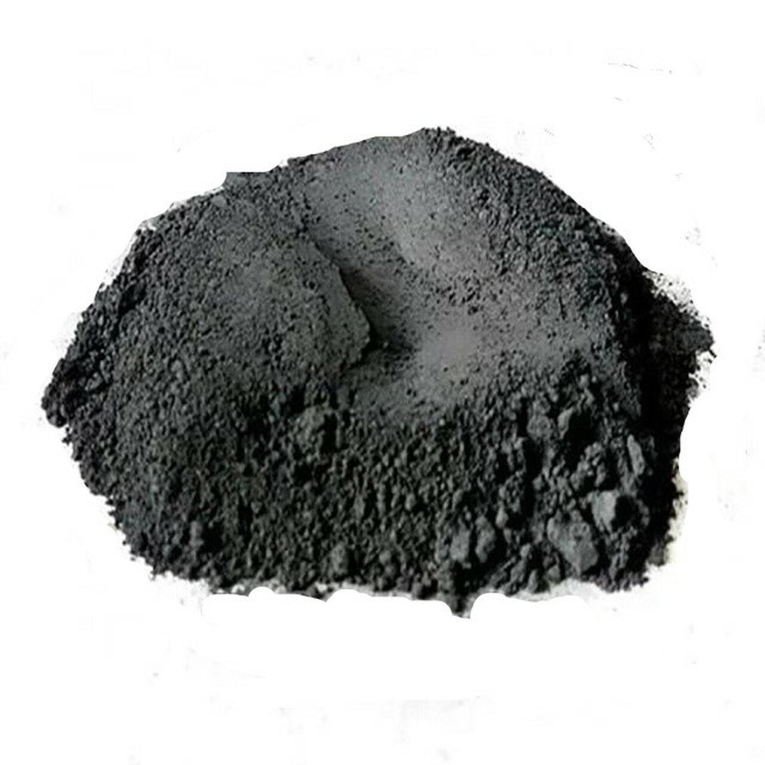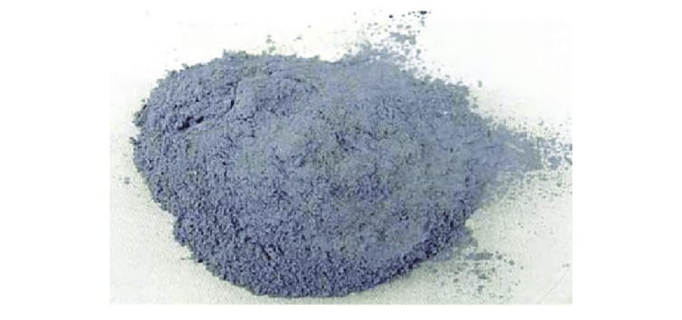
Molybdenum disulfide Silicon nitrate
The reinforcement powders are initially subjected to ball milling (Fritsch, Germany, Planetary mono mill classic line pulverisette-6) to reduce the size of MoS₂ and Si₃N₄ to 30 and 25 microns respectively. The stir casting set up consists of a crucible made of graphite in which the required aluminium is placed and it is heated up to 750ºC in a muffle furnace. The reinforcement powders are heated in another set of crucible up to 400ºC for 1hour for oxidizing the surfaces. After attaining the desired temperature,the molten metal is mixed with the heated reinforcement powder with the help of the mechanical stirrer at 350 rpm for 5 mins in order to have the uniform distribution over the work piece. The process is repeated for the specimens of various wt%. The molten metal is poured into the rectangular mould of dimension 100*100*10mm.

3.4. FABRICATION OFCOMPONENTS
Stir casting is a liquid metallurgy method of composite material fabrication, in which a dispersed phase like ceramic particles, short fibers is mixed with a molten matrix metal by means of a mechanical stirring. The stir casting arrangements is shown in figure. It is effectively mixing the reinforcement material with the matrix material (i.e. Al alloy) and does not damage the reinforcements while stirring.
Stir casting provides better bonding between matrix and reinforcing material due to the stirring action. Stir casting, as an alternative and relatively simple route can be successfully used to produce metal matrix composite. A recent development in stir casting process is a double stir casting or two-step mixing process.
In this process, first the matrix material is heated to above its liquid’s temperature. The melt is then cooled down to a temperature between the liquids and solidus points to a semi-solid state. At this point the preheated reinforcement particles are added and mixed.
The proper mixture of hard particulate not only reduces interfacial energy but also prevents chemical interaction between the dispersed phase and the matrix in a crucible furnace. Aluminium LM-13 alloy as matrix, Molybdenum disulfide(MoS₂) and Silicon nitride(Si₃N₄) as reinforcement consists of different weight ratios (0, 2.5, 5,7.5 and 10 wt.%) are utilised for the preparation of hybrid composite materials. Initially, the reinforcement particles are pre-heated individually at a temperature of 250*C to reduce dampness and improve wettability with the molten aluminium A356alloy.
The argon-gas is charged into a crucible furnace and aluminium alloy is heated above the liquidus temperature (i.e. >650 ◦C) is embedded and alloy melts completely.
The liquid aluminium alloy was then cooled in solid state

solid state at 600 ◦C temperature illustrate. The pre-heated reinforcement particles are added at this temperature and stirring of the slurry was performed for 10 min manually. The second process was performed by using mechanical stirrer at a speed of 400 rpm for 15 min and the composite slurry was superheated at 720 ◦C temperature helps to improve the distribution of reinforcement particles in the aluminium based composite. Therefore finally, the molten metal was transmitted into the die to make a specimen in desired shape and size inserted with metallic chills to increase the solidification rate in hybrid composite material.

3.6. Drilling EDM machine setup
EDM hole drilling experiments are carried out in Sparkonix DSH II EDM machine .Rotary tubular copper electrode of diameter 1.5 mm, length 400 mm and 100 rpm speed is used to create series of through holes in LM13–10Si₃N₄–5MoS₂composite. The machine has six current settings from 1 to 25 A (1 A, 2 A, 4 A, 6 A, 6 A, 6 A) and variable ten settings for Ton and Toff in steps of 1 µs (from 1 to 10 µs). During the machining operation, the workpiece is connected to positive terminal and the tool electrode is connected to negative terminal. Deionized water is used as dielectric agent and flushed through the cavity of electrode to remove the eroded materials from the machining zone with a constant flushing pressure of 50 kg/cm2 for stable machining and cooling the electrodes.

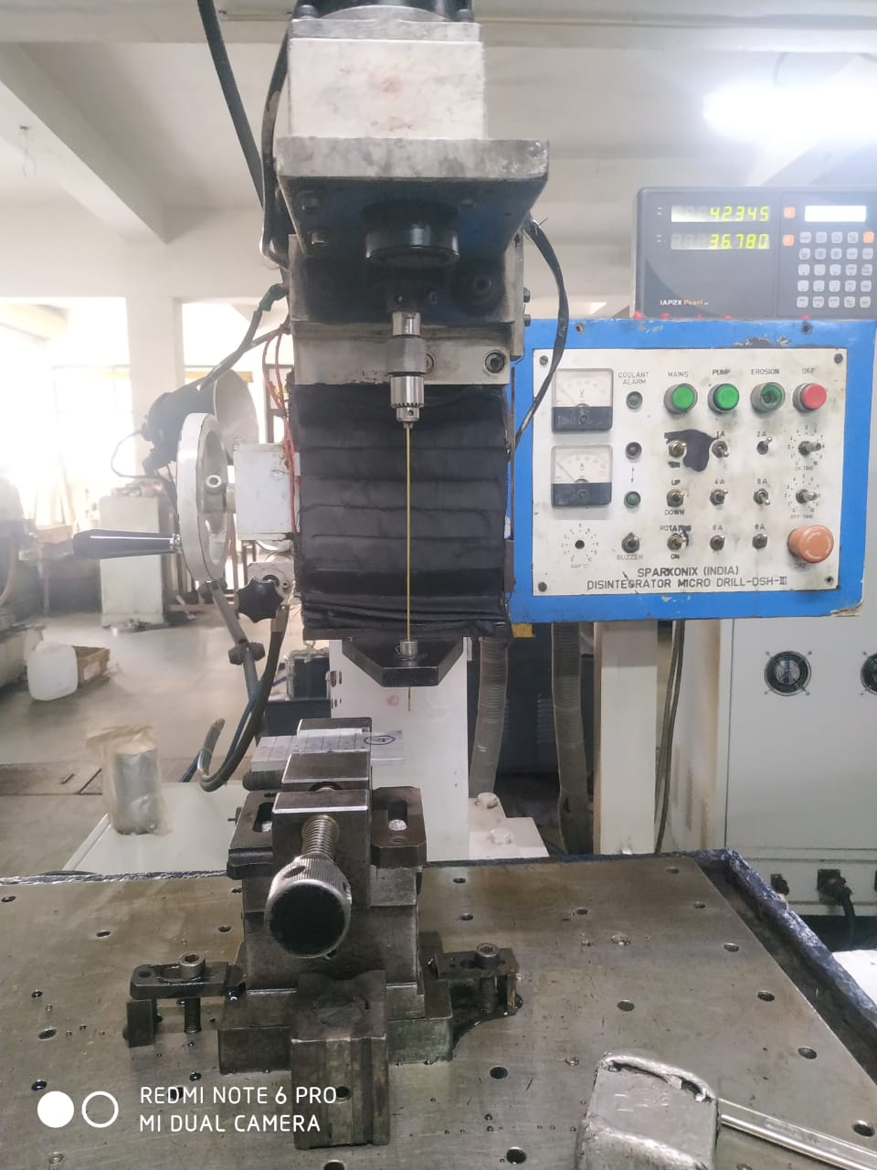

3.6.1. General specification about EDM machine.

Mechanism of process | Controlled erosion (melting and evaporation) through a series of electric spark
Spark gap | 0.010- 0.500 mm
Spark frequency | 200 – 500 kHz
Peak voltage across the gap | 30- 250 V
Metal removal rate (max.) | 5000 mm3/min
Specific power consumption | 2-10 W/mm3/min
Tool material | graphite,
TWR | 0.1-10 mm3/min
Materials that can be machined | All conducting metals and alloys.
Shapes | Microholes, narrow slots, blind cavities
Limitations | High specific energy consumption, nonconductingmaterials can’t be machined.

3.6.2. Experimental parameters and their levels
EDM process performance is influenced by various electrical and nonelectrical controllable parameters such as discharge current, flushing pressure, electrode geometry, pulse on-time, polarity, pulse interval, open discharge voltage, etc. It is a complex task to show the impact of all process parameters on the performance criteria. In this work, the primary EDM electrical process parameters such as current, pulse duration/pulse on-time and pulse interval/pulse of-time are chosen based on their significant influence on machining performance characteristics . Based on exploratory trial experiments and capacity of the machine setup, the appropriate range for process parameters was selected.
The current value of greater than 5 A is selected in this study, because there is no major change in material removal and it also takes longer time for machining when the current values are taken below5 A. Similarly, higher levels of current, i.e. greater than 23 A, are not considered due to its erratic discharge energy which may deteriorate the quality of holes produced and the electrodes. Based on the available settings
for Ton and Tof in the machine, 3–9 µs is selected for main experimentation in order to get better optimized value of parameters. Table 2 shows both coded and actual values of process variables considered in this study for making drills in LM13–10Si₃N₄–5MoS₂ composite.

3.6.3. Experimental design for machining LM13–10Si₃N₄–5MoS₂ composites
Full-factorial rotatable central composite design (CCD) of response surface methodology (RSM) is used to design the experiments. Based on the number of controllable factors, 20 experimental runs are created with different combinations of factors (independent variables) at fve variation levels. The design includes eight factorial points having ±1 levels, six star points with alpha value of ±1.682 and six centrepoints which denote replicated experiments for estimation of repeatability.
Experiments are conducted in randomized manner, and the efect of selected process parameters on machining and dimensional characteristics, namely MRR, EWR and OC, is studied. The designed combination of parameters for experimentation along with its corresponding measured response values is presented in Table 3. Moreover, experimental design and the analysis of results presented in this work are carried out using Design Expert 10 software.

3.7. Evaluation method of machining performances
The performance of hole drilling EDM process in machining of LM13–10Si₃N₄–5MoS₂ hybrid composite is evaluated by considering the following response variables in the aspects of productivity and hole quality such as MRR, EWR .

3.7.1.Material removal rate
Material removal rate (MRR) is expressed as volume of material removed from the work piece per drilling time, and it is calculat. Machined volume from the work piece is evaluated through the dimensions of entrance and exit diameter of each hole. The diameter is examined by tracing eight different nodal locations of a hole by utilizing coordinate measuring machine (CMM, Make: Zeiss, Model: Contora G2) with an accuracy of 2 µm, and the average value is considered. CMM equipped with calypso 5.8 software during measurement is shown. Machining time for each test is measured using electronic timer:

Material removal rate = ∗t( HD²t + HD²b + HDt ∗HDb)
12*T
Where,
HDt - entrance diameter of hole produced in mm
HDb- exit diameter of hole produced in mm,
T- machining time to make a through hole in seconds
t - the work piece thickness in mm.

3.7.2. Electrode wear rate
It is expressed as the ratio of electrode length consumed to the machining time. Length of the electrode consumed is calculated as shown in Eq. 3.Before drilling, the value of z coordinate axis is set to zero and after drilling the value of electrode movement in z direction is measured directly with the aid of digital control panel in hole drilling EDM machine.
Electrode wear rate = Electrode length consumed(Le)
Machining Time (T)
Le = Electrode movement inzdirection−hole depth.

CHAPTER 4
4. RESULTS AND DISCUSSION
4.2. ELECTRIC DISCHARGE MACHINE
All the five combination of composites were machined with graphite electrodes of diameter 1.5 mm. The effect of the tube electrode in machining of the above composites was tested by measuring the MRR, EWR while varying the input variables. The input variables selected for this study are current,pulse on and pulse off.
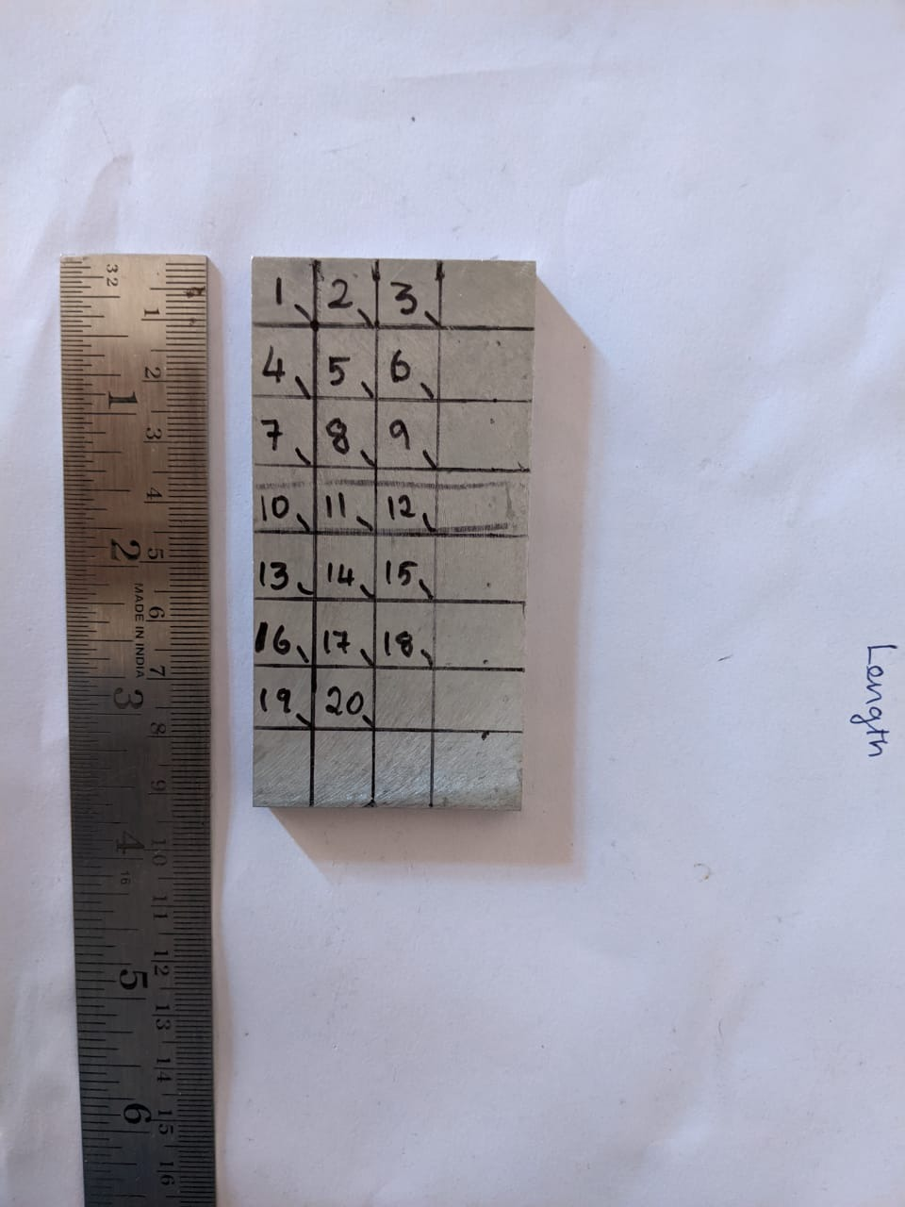

A Copper and Brass electrode is constantly rotated as the dielectric fluid is pumped through the electrode. The rotating helps in producing concentricity, causing even wear and helps in the flushing process. EDM Drilling can penetrate much deeper than almost 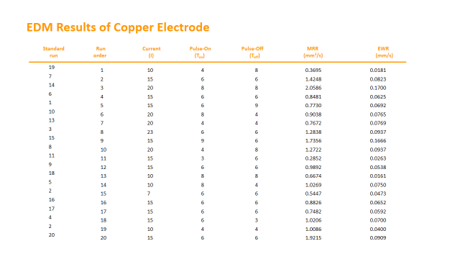

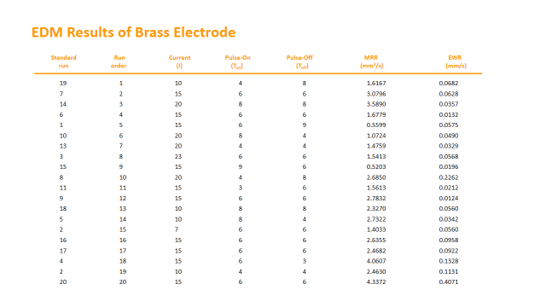

4.2.1 Effect of independent process variables on MRR

The interaction graph of I and Ton on MRR is presented in Fig. It is evident that material removal rate shows a linearly increasing trend with increase in pulse current for all levels of Ton. This is due to the rapid increase in energy intensity of a spark which produces high thermal energy, resulting in the melting and vaporization of materials from the work piece. Moreover, the effect of pulse on-time on material removal rate shows an increasing trend of up to Ton of 7 µs and after that it starts to decrease slightly.

This is because when the pulse on-time is increased, the amount of material removal also increases from the work piece due to high penetration time for thermal energy into the work piece which causes melting and enhances material removal. Onthe other hand, due to inadequate flushing time, the coarse debris between the electrodes obstructs the effective dis- charge energy released from the electrode to contact the work material which in turn reduces MRR after 7 µs of Ton. Similar kind of observation at high levels of Ton with constant Toff for MRR was reported.

In contrast, at lower level of Ton, heat energy conducted into the work piece was trivial due to less machining time. As a result, slight increase in MRR was witnessed with increase in current relative to other levels of Ton.

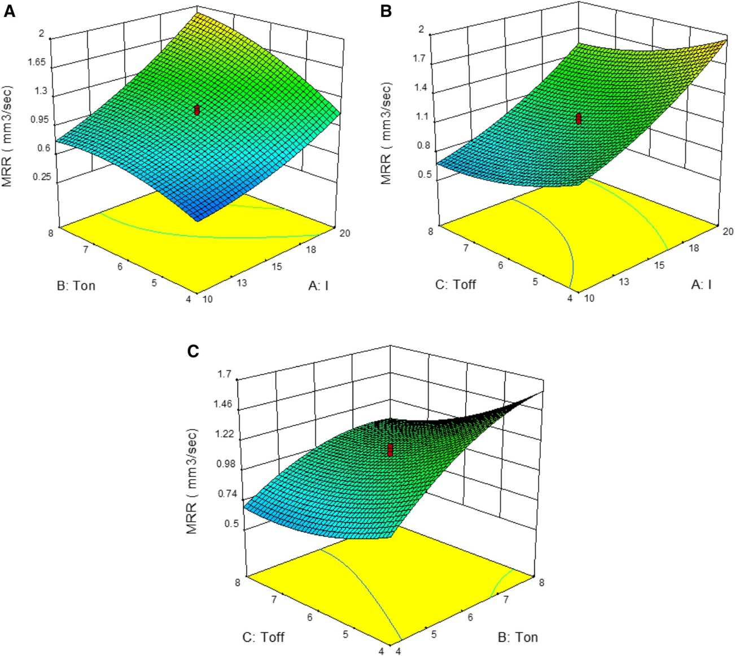

Itshows the interaction effect of I and Toff onMRR. It is observed that the increase in current shows asignificant rise in MRR at low level of Toff and it gradually reduces with increase in Toff. This phenomenon may beattributed to decrease in spark frequency, higher machiningtime and heat dissipation as Toff increases [8, 36]. All thesefactors combined together lead to the reduction in material removal rate.
The pulse-on time is found to be the leastsignificant factor having only 11% contribution for MRR, whereas I and Ton have 53.2% and 19.8%, respectively. Fig- ure 9c shows the interaction effect of Ton and Toff on MRR. It is clear that increase in Ton increases the MRR considerably at low level of Toff, relative to other levels of Toff.
4.2.2 EffectofindependentprocessvariablesonEWR
The interaction graph of I and Ton on EWR is presented in Fig. 10a. It is observed from the figure that the value of electrode wear rate increases proportionally with increase in current for all the levels of Ton. This trend is attributed to the release of higher number of charged particles (electrons and ions) at the interface between work piece and tool electrode with increase in current. The movement of high-energy charges in the plasma channel generates a substantial amount of heat around the electrode surface, resulting in high elect- trode wear at high levels of current. It is also observed from Fig. that there is a gradual increase in the electrode wearrate with an increase in pulse on-time. This may be due to the action of longer sparking time, which eventually results in high heat energy and softening of the electrode mate- rial. Moreover, the produced coarse debris between tool and workpiece at higher levels of pulse on-time may also tend to increase electrode wear due to arcing.

Figure shows the interaction effect of I and Toff on EWR. It is observed that EWR increases with increase in current for all the levels of Toff. In addition, it is also observed that EWR gradually reduced with increase in Toff and it is due to sufficient cooling time around the electrode and less sparking energy. On the other hand, a slight increase in EWR is also noticed at higher levels of Toff (i.e. greater than 7 µs). This may be due to the greater degree of fluctuation in thermal and spark energy at higher levels of Toff.
Therefore, more energy is required to establish the plasma channel, which in turnleads to increase in the electrode wear. The pulse off-time is found to be least significant factor having only 9% contribution for EWR, whereas I andTon have 43% and 36%, respectively. Figure shows the interaction effect of Ton and Toff on EWR. It is clear that increase in Ton increases the EWRconsiderably at low level of Toff, relative to other levels of Toff.

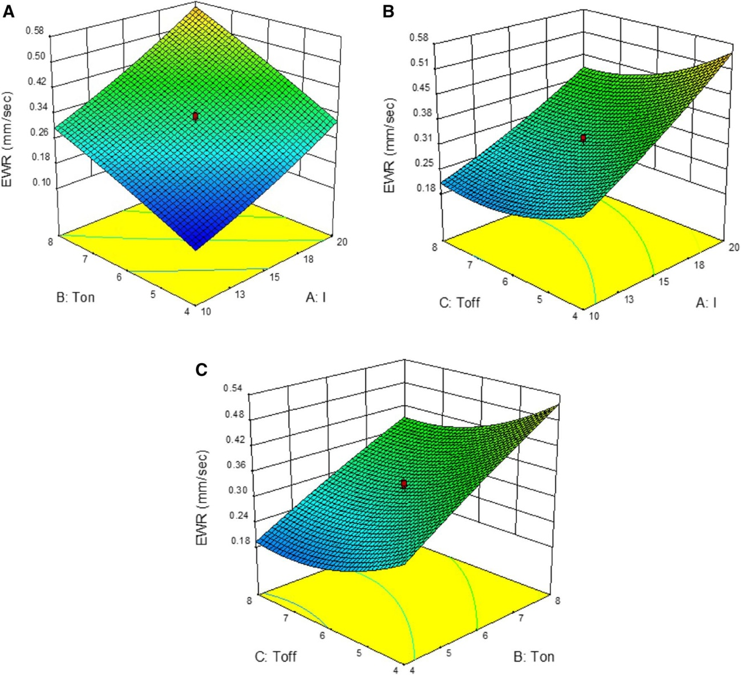

CHAPTER 5
CONCLUSION
- Hybrid composites revealed excellent impact strength than single reinforced composite. As compared to unreinforced LM13 aluminium alloy, the hardness, ultimate tensile strength and wear resistance of LM13-MoS₂-Si₃N₄ hybrid composite substantially increased up to 63%, 49% and 69% respectively. Hence, the hybrid composite can be used in various applications because of its excellent mechanical and tribological properties.

- The impact strength of the composite was increased by adding the metallic reinforcement.

- Combination of ceramic and metallic reinforced structural based aluminium composite was successfully fabricated.Optical micro-structure shows the perfect mixing of reinforcement with AL- LM-13 alloy.

- Density of structure based aluminium composites was increased with varying percentage of metallic reinforcement and the porosity level was increased. The impact strength of composite decreased as compare with unreinforced base metal, because of the agglomeration of reinforcement at the grain boundaries.

- MRR is highly infuenced by current, followed by pulse duration and pulse interval with percentage contribution of 53.2%, 19.8% and 11%, respectively.

- Similarly, EWR is highly infuenced by current, followed by pulse duration and pulse interval with percentage contribution of 43%, 36% and 9%, respectively.

- The results obtained from this study would be useful and provided as a technical database for automobile and aerospace industries in the aspect of EDM drilling of hybrid LM13 aluminium alloy-based composites with conficting objectives such as maximum MRR, minimum EWR .

REFERENCES
- Chawla,K.,1998,"CompositeMaterial:ScienceandEngineering,"Springer,New York. ISBN 978-0-387-74365-3
- Narayan, S., and Rajeshkannan, A., 2017 "Hardness, tensile and impact behaviour of hot forged aluminium metal matrix composites," Journal of Materials Research and Technology, JMRTEC-240. DOI:10.1016/j.jmrt.2016.09.006
- Chaubey,A.K., Gokuldoss,K.P., Zhi Wang,Z., Scudino,S., Mukhopadhyay,K.N., and Eckert,J., 2016, "Effect of Particle Size on Microstructure and Mechanical Properties of Al-Based Composite Reinforced with 10 Vol.% Mechanically Alloyed Mg-7.4%Al Particles," Technologies, 4,37, pp.1-8. DOI: 10.3390/technologies4040037
- Kok,M., 2005, "Production and Mechanical properties of Al2O3 particle – reinforced 2024 aluminium alloy composites," Journal of Materials Processing Technology, 161, pp.381-387. DOI:10.1016/j.jmatprotec.2004.07.068
- Anilkumar,H.C., Hebber, H.S., and Ravishankar, K.S., 2011, "Mechanical Properties of Fly Ash Reinforced Aluminium alloy (AA6061) Composites," International Journal of Mechanical and Materials Engineering, 6,pp.41-45. reinforced Metal Matrix Composites," Journal of Material Science, 27(22), pp.5965-5981.

- Singer,A.R.E.,and Ozbek, S.,2013, "Metal Matrix Composites Produced by Spray Codeposition," Journal of Powder Metallurgy,pp.72-78.
- Bodunrin MO, Alaneme KK, Chown LH (2015) Aluminium matrix hybrid composites: a review of reinforcement philosophies; Mechanical, corrosion and tribological characteristics. J Mater Res Technol 4:434–445. https://doi.org/10.1016/j.jmrt.2015.05.003
- Senthilkumar TS, Muralikannan R (2019) Enhancing the geometric tolerance of aluminium hybrid metal matrix composite using EDM process. J Braz Soc Mech Sci Eng.https://doi.org/10.1007/s40430-018-1553-2
- Samson Jerold Samuel C, Ramesh A, Arunprasad N, Thangaraj AN, Harishankar S (2017) Dry sliding wear characterization of squeeze cast LM13/FeCu composite using response surface methodology. China Foundry 14:525–533. https://doi.org/10.1007/s41230-017-7101
- Kumar NM, Senthil Kumaran S, Kumaraswamidhas LA (2016) High temperature investigation on EDM process of Al 2618alloy reinforced with Si3N4, ALN and ZrB2 in-situ composites. J Alloys Compd 663:755–768. https://doi.org/10.1016/j.jallcom.2015.12.175
- Mazaheri Y, Meratian M, Emadi R, Najarian AR (2013) Comparison of microstructural and mechanical properties of Al–TiC, Al–B4C and Al–TiC–B4C composites prepared by casting techniques.
Mater Sci Eng A 560:278–287. https://doi.org/10.1016/j.msea.2012.09.068
- Moses JJ, Dinaharan I, Sekhar SJ (2016) Prediction of infuence of process parameters on tensile strength of AA6061/TiC aluminum matrix composites produced using stir casting. Trans Nonferrous Met Soc China 26:1498–1511. https://doi.org/10.1016/s1003-6326(16)64256-5
- Pridhar T, Sankaran R, Ravikumar K, Boopathi C (2016) The efect of particle hybridization on micro structure analysis and mechanical behavior of metal matrix composites: an experimental approach. Dig J Nanomater Biostruct 11:845–852
- Daneshmand S, Masoudi B, Monfared V (2017) Electrical discharge machining of Al/7.5% Al2O3 MMCs using rotary tool and Al2O3 powder. Surf Rev Lett 24:1–17. https://doi.org/10.1142/s0218625x17500184
- Chiang KT (2008) Modeling and analysis of the efects of machining parameters on the performance characteristics in the EDM process of Al2O3+TiC mixed ceramic. Int J Adv Manuf Technol 37:523–533. https://doi.org/10.1007/s00170-007-1002-3
- Ponappa K, Aravindan S, Rao PV, Ramkumar J, Gupta M (2010) The efect of process parameters on machining of magnesium nano alumina composites through EDM. Int J Adv Manuf Technol 46:1035–1042. https://doi.org/10.1007/s00170-009-2158-9
- Lin YC, Wang AC, Wang DA, Chen CC (2009) Machining performance and optimizing machining parameters of Al2O3-tic ceramics using edm based on the taguchi method. Mater Manuf Process 24:667–674. https://doi.org/10.1080/10426910902769285
- Sai Krupa M, Dileep Kumar N, Suresh Kumar R, Chakravarthy P, Venkateswarlu K (2013) Efect of zirconium diboride addition on the properties of silicon carbide composites. Ceram Int 39:9567–9574. https://doi.org/10.1016/j.ceramint.2013.05.075
- Yilmaz O, Bozdana AT, Okka MA (2014) An intelligent and automated system for electrical discharge drilling of aerospace alloys: Inconel 718 and Ti–6Al–4V. Int J Adv Manuf Technol 74:1323–1336. https://doi.org/10.1007/s00170-014-6059-1
- Suresh P, Venkatesan R, Sekar T, Elango N, Sathiyamoorthy V (2014) Optimization of intervening variables in MicroEDM of SS 316L using a genetic algorithm and response-surface methodology. J Mech Eng 60:656–664. https://doi.org/10.5545/ sv-jme.2014.1665

